## **Self-Reflection: Dive deeper into dashboards**

.

Question 1



## Benefits of a dashboard



Previously, you were introduced to the data management tool known as a dashboard. In short, a dashboard is a single point of access for managing a business's information. It allows people to pull key information from data at a glance by visualizing the data in a way that makes things obvious or easy to understand.

In this activity, you’ll examine a few different kinds of dashboards and consider how they are used by data analysts and their teams.

### Reflection



Before we go on, in the box below brainstorm any benefits that a company might gain from using a dashboard.

Also, write 2-3 sentences (40-60 words) outlining an example of a data source a company might use with a dashboard, and how they would benefit from it.

There are numerous benefits to a company that can be provided by a dashboard, such as:

* Track historical and current performance
* Establish both long-term and/or short-term goals
* Define key performance indicators or metrics
* Identify potential issues or points of inefficiency

2.

Question 2

### Reflection



Make a list or write 2-3 sentences (40-60 words) with examples of industries or businesses that could benefit from using dashboards more than others.

While almost every company can benefit in some way from using a dashboard, larger companies and companies with a wider range of products or services will likely benefit more. Companies operating in volatile, or swiftly changing markets like marketing, sales, and tech also tend to benefit more.

3.

Question 3

## Types of dashboards



Often, businesses will tailor a dashboard for a specific purpose. The three most common categories are:

1. Strategic: Focuses on long term goals and strategies at the highest level of metrics
2. Operational: Short-term performance tracking and intermediate goals
3. Analytical: Consists of the datasets and the mathematics used in these sets

Let’s go into more detail about these three kinds of dashboards.

Strategic dashboards



A wide range of businesses use strategic dashboards when evaluating and aligning their strategic goals. These dashboards provide information over the longest time frame — from a single financial quarter to years. They typically contain information that is useful for enterprise-wide decision-making. An example of such a dashboard is below, which focuses on key performance indicators (KPIs) over a year.

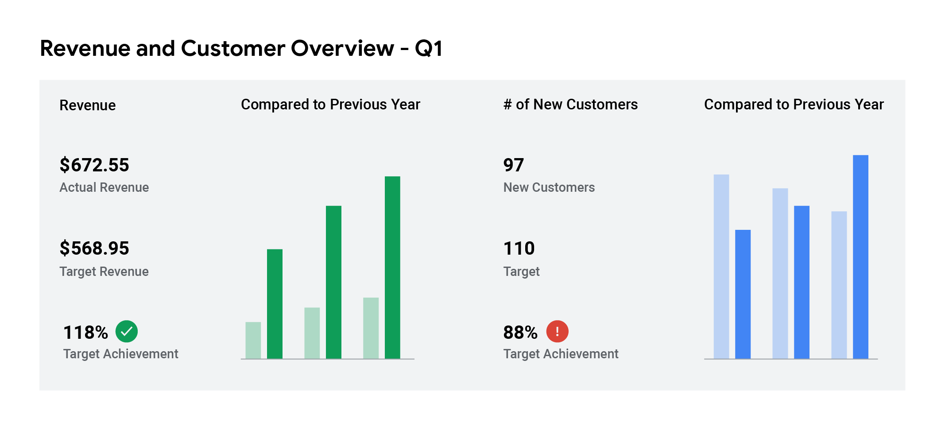

Operational dashboards



Operational dashboards are, arguably, the most common type of dashboard. Because these dashboards contain information on a time scale of days, weeks, or months, they can provide performance insight almost in real-time. This allows businesses to track and maintain their immediate operational processes in light of their strategic goals. The operational dashboard below focuses on customer service.

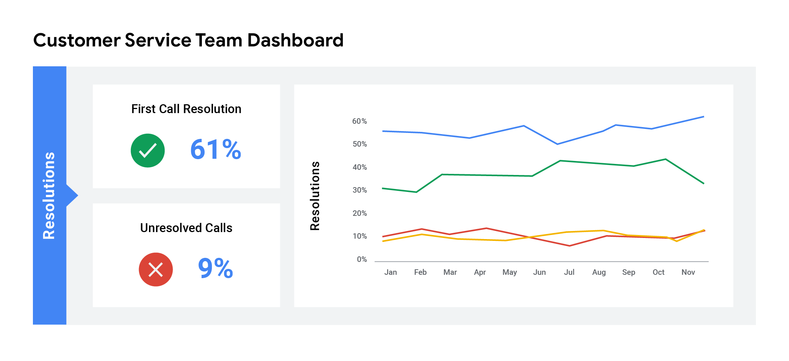

Resolutions are divided between first call resolution (61%) and unresolved calls (9%)

Analytical dashboards



Analytical dashboards contain the details involved in the usage, analysis, and predictions made by data scientists. Certainly the most technical category, analytic dashboards are usually created and maintained by data science teams and rarely shared with upper management as they can be very difficult to understand.

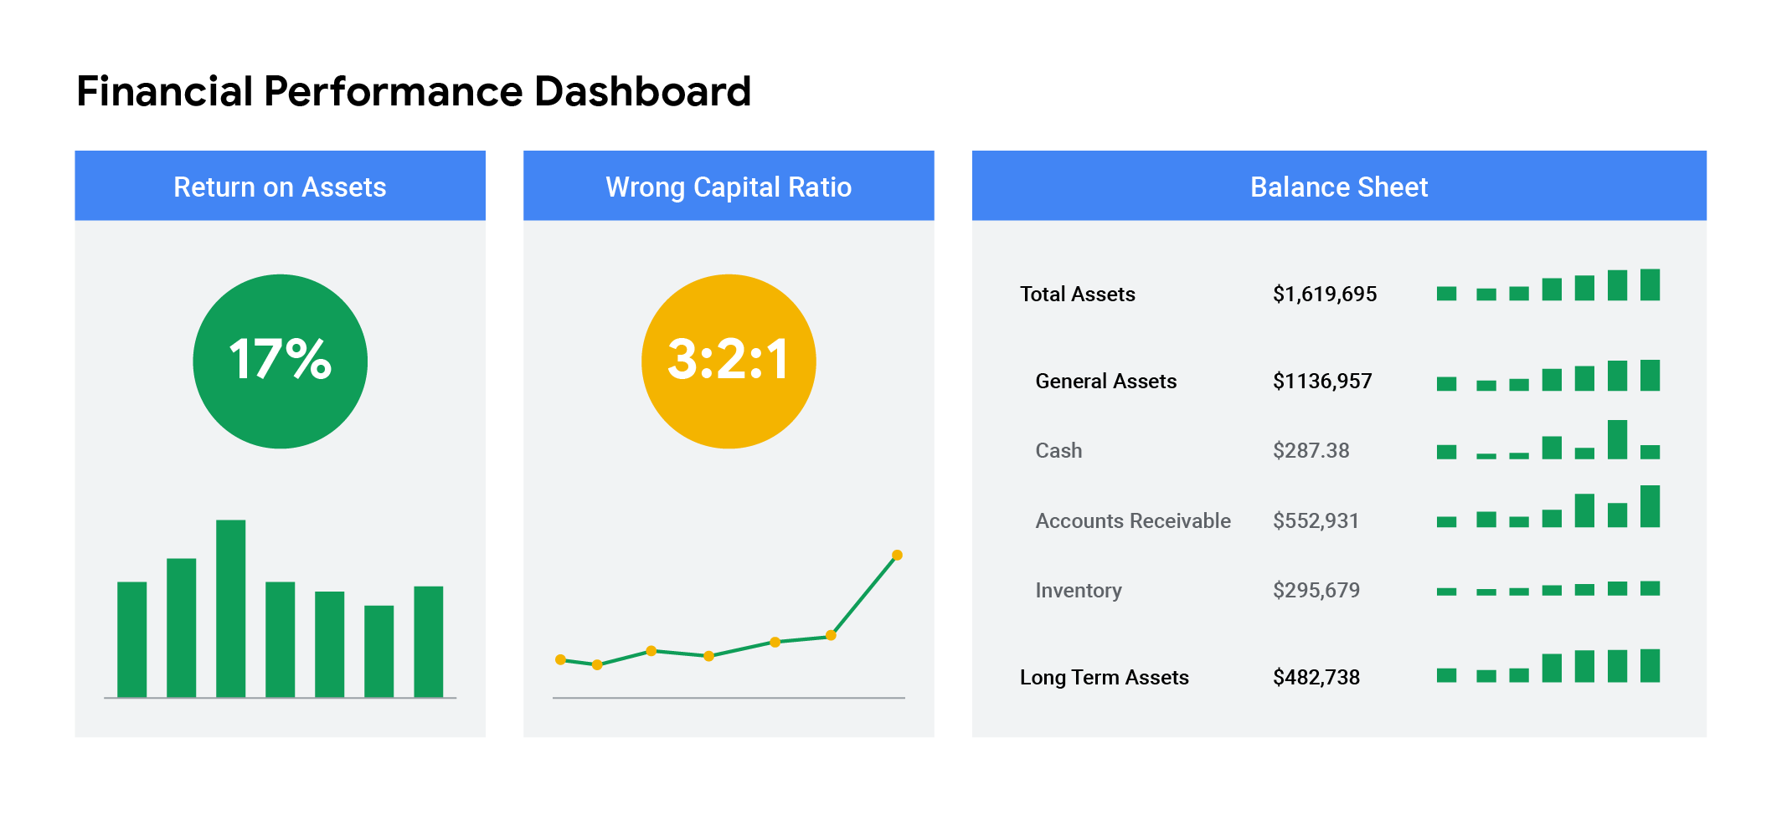

Contains Return on assets, wrong capital ratio, and balance sheet

### Reflection



After examining these dashboard examples, write 2-3 sentences (40-60 words) explaining their similarities and differences.

A few commonalities in these examples include:

* Dashboards are visualizations. Visualizing data can be enormously valuable in understanding what the data really means.
* Each dashboard identifies relevant metrics that may be used to assess company performance.

As for differences, the most obvious one is the timeframe covered in each dashboard. The operational dashboard has a timeframe of days and weeks, while the strategic dashboard displays the entire year. The analytic dashboard skips a specific timeframe and instead identifies and tracks the various KPIs that may be used in the assessment of strategic and operational goals.

4.

Question 4

### Reflection



Think about the person you had your data conversation with previously and write 2-3 sentences (40-60 words) explaining what dashboard you would recommend for that person.